Karen’s Kounsel
July 2013 Page 1 of 2

KLynn Counseling
a place for new beginnings

“Adoption is wonderful and beautiful and the greatest blessing I have ever experienced. Adoption is also difficult and painful. Adoption is a beautiful picture of redemption.”
Katie Davis, Kisses from Katie: A Story of Relentless Love and Redemption
You have taken on an awesome responsibility, and a wonderful adventure. There are great joys in raising a child that you have chosen and accepted into your family. These are children that had nowhere to go and had no one to depend on. You have made the decision to open your heart and your home, much in the same way God has done for us. We were left alone in a world filled with pitfalls and no hope and He chose us and adopted us into his family. Galatians 4:5 To redeem them that were under the law, that we might receive the adoption of sons
In doing this you will encounter trials that may come as a surprise to you. They are also difficulties that other parents who have their own biological children may not understand. It is important to remember that the one that you have chosen to parent was subjected to trauma before you came into his or her life. That trauma has had an impact, whether or not there is memory of it. It has affected the chemical and physical make up of their brain. Many times it triggers a “flight or fight” response that causes them to feel as if they are continually on “high alert”. They will perceive situations in different ways than others do. And this is NOT your fault. It is not due to your parenting. But there are ways to help your child, and the first key is to understand what’s going on.
If they are controlling, it is because there was a time when they were powerless to stop what was happening to them and they had no control. Some of the children I have worked with have recounted terrifying stories that have left them with little trust. That trust must be rebuilt and it can be a slow process at times. When they appear to be shut down, in a way that others will perceive as “lazy”, it can stem from the feeling of hopelessness. There is little motivation when you do not believe that anything can truly change. When they rage and scream, it is because at one time they did not have a voice. What they said fell on deaf ears. When they cried there may have been no answer.
For these patterns to change it takes time. They are deeply ingrained. Begin by realizing that many of the reactions you see are based and rooted in fear. The anger you see grows out of fear. What appears as lack of feeling or an inability to relate is a wall that has been erected out of fear. So what is the answer to this? The answer is as simple as it is difficult. Unconditional love. The words are easy to say. Not always as easy to do. God’s word tells us: There is no fear in love; but perfect love casts out fear: because fear has torment. He that fears is not made perfect in love. 1 John 4:18
One of the first ways to do this is to get past the behavior and build a connection with your child. Don’t try to correct or instruct them in the middle of a crisis. First try to calm your child and connect with them. The emotional dysfunction they are in the middle of is not excused by their past trauma but needs to be understood. Speak to that first and help them to calm down. The teaching moment can come later. When you have succeeded in connecting and calming, then you can coach them in a better way to respond and why they should respond differently.
This is very basic advice and the actual executing of it can become complex and emotionally straining. It is important when dealing with a child who has been exposed to trauma that you find ways to deal with your own feelings of being overwhelmed. Find ways to unwind, refresh, and get some support. You cannot calm someone else if you are not calm yourself. “I believe one of the most sacrificial acts of love adoptive parents can do is to give up their preconceptions and agendas about what their child's views "should" be and be open to hear the conflicting emotions and thoughts their child often experiences.” Sherrie Eldridge, Twenty Things Adopted Kids Wish Their Adoptive Parents Knew
This can be a learning experience for all of you. Some of these behaviors can trigger old wounds and past traumas that you went through yourself. If that is the case, then view this as a time for not just your child to find wholeness, but your time for healing also. Let it give you the perspective of a deeper understanding and compassion for what they have been through. Take the time to work through the issues one step at a time. Most importantly, don’t try to struggle through alone. Find a support group, get some caring competent counsel, and connect with other adoptive parents. You have an opportunity to walk in the steps of our Heavenly Father. There may be some storms to weather, but there are also tremendous rewards.
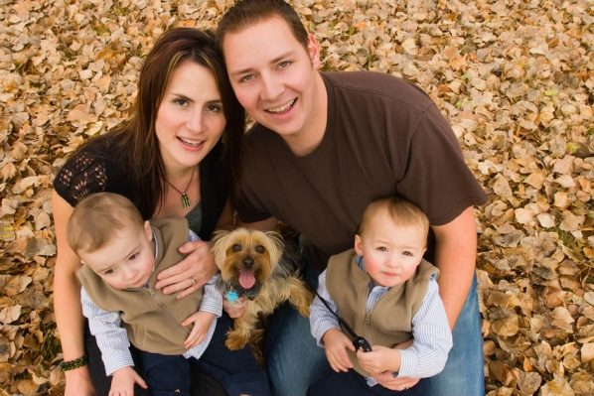
“Even though you weren't born to us, you grew in our hearts. We will be forever connected because love is what makes a family.”
Deanna Kahler, From Pain to Parenthood

