Karen’s Kounsel
July 2012 Page 1 of 2

KLynn Counseling
a place for new beginnings

When it comes to controlling human beings, there is no better instrument than lies. Because you see, humans live by beliefs. And beliefs can be manipulated. The power to manipulate beliefs is the only thing that counts.
Michael Ende

This month we are continuing to look at setting boundaries in our lives. We will explore some of the basic ideas that help us understand why boundaries are important, why it can be so hard to establish them, and the part that control and manipulation play.

If someone has been raised in a dysfunctional home, many times boundaries can be a foreign concept. If as a child, your boundaries were crossed over or trampled on time and time again, this can feel like a “normal” way of life. In fact, to begin to set boundaries can feel mean, unloving, or irresponsible. It can leave you feeling guilt laden. Let’s begin with some of the basic principles starting with this idea of responsibility and how that relates to being a loving person.

We do have the responsibility to love others. We do have the responsibility to help those around us who are in need. But we also have a responsibility to live our lives by the direction of our Heavenly Father who has the perfect plan for our lives. When others demand more of us than is appropriate it is not only OK to set boundaries, it is the loving thing to do.
It is not loving to play the part of God in someone else’s life. When we constantly leap in to do for them what they should honestly be doing for themselves, we not only hinder their growth as a person but we set ourselves up as God in their life. It is God who supplies our needs, and in His love he takes us along paths that promote our growth, our development, and our healing. Those paths are seldom easy, but they are always for our good.

Now when I say that they are seldom easy, I am not confusing the times when we go off on our own way apart from God and bring heartache on ourselves. Scripture is clear about the way of the rebellious being hard. “Good understanding giveth favor: but the way of transgressors is hard”. Proverbs 13:15.

But never forget that when we come to Him in repentance He is always ready to forgive and help us in whatever difficulty we find ourselves in. This is the process of God’s working in our life. It is the way we grow in faith and as human beings.

If you have ever watched a child who has been given everything he has ever asked for with nothing being required of him you will see clearly the results of someone not letting that process take place. We should be careful not to make too much of a presumption about our own importance. It is such an easy thing when someone begins to depend on us more than is healthy, for that to stroke our ego. It makes us feel important and indispensible. It fills some of the gaps in our own wounded heart that we actually need to let God Himself fill. Psychology calls this co-dependence, and it is usually most evident in a family where there has been either alcohol or substance abuse or physical and/or sexual abuse.

When boundaries are continually crossed, there is an issue of control involved. When control is involved there is, as the opening quote so bluntly states, some incorrect belief involved. The person crossing the boundaries is projecting the belief that he or she is unable to handle a situation themselves, will fall apart if you don’t step in, or that for some reason you “owe” them. They may be so used to being in this role that they may not even realize that they are manipulating the situation. You may have been in this pattern with them for so long, you may not be sure what they are actually capable of or exactly why you owe them. Guilt usually leaps into the mix and seals the deal.

Control in its ultimate form is slavery. It seeks to dominate another person for its own benefit. Unfortunately, there is, in reality, no benefit to either party – the controlled or the controller. It brings poverty, squelches creativity, and it saps the life out of faith and spirituality.

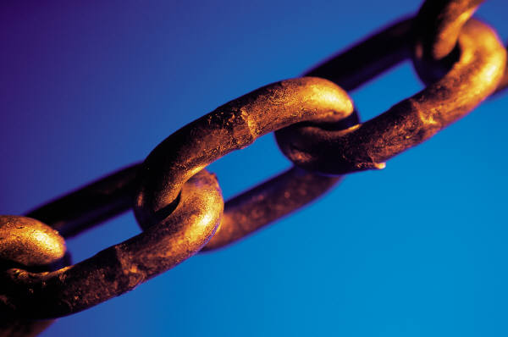

A glaring example of this is the slavery that existed in our own country. How many great minds such as George Washington Carver were totally wasted because they were forbidden a basic education? How much could have been discovered, invented, created that would have benefited not only the South, but perhaps the world? It was a tremendous loss that could never be made up by the profit of the free labor that was gained. In fact, some of the areas that appeared to be the wealthiest because of this slave labor are to this day some of the poorest in the nation.

Control/slavery promotes a mindset that refuses to move on and progress. It is an entrapment for everyone involved. And what spiritual damage is done to the soul of someone who continually dominates and controls another person? They develop a god-like complex thinking that they alone know what is best for that person. That is a position reserved only for God Himself. For a scriptural example of how that works out in a person’s life check out Daniel chapter 4. (My advice would be to avoid this mindset at all costs!)

Our response to others around us should reflect love – a love that wants the ultimate best for another person. When you lovingly begin to set boundaries with someone, you may hear some statements such as, “If you really loved me you would. . .” or “Don’t you care?” or “If you do that, I won’t be seeing you again”. Love still does what’s best for that person even if we have to deal with their anger.

On the other hand, are you the one making those kinds of statements? If so, I urge you to take a good look at how this is affecting your relationships. It is probably draining the joy out of them. Do you want others chained to you out of guilt alone or do you want solid, loving, reciprocal bonds with your family and friends? It is almost a sure thing that you are more capable and resourceful than you ever imagined. Step out and try walking on your own. I could turn out to be a positive growing experience.
If your problems in this area are a result of abuse, or you feel that you are putting yourself in danger by taking some of these steps we have discussed here, PLEASE, seek appropriate help - a pastor, a trusted friend, a counselor, or even the authorities if need be. And always remember. . .

It is for freedom that Christ has set us free. Stand firm, then, and do not let yourselves be burdened again by a yoke of slavery. Galatians 5:1

