Karen’s Kounsel
June 2012 Page 1 of 2

KLynn Counseling
a place for new beginnings

“Good fences make good neighbors”
Robert Frost

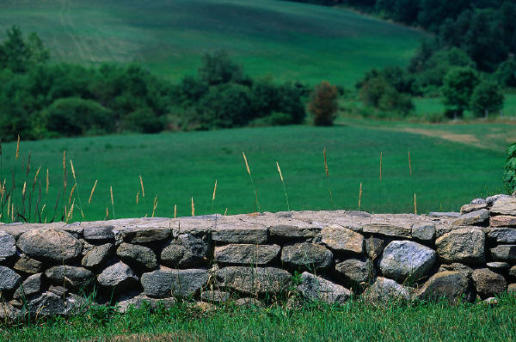

In Robert Frost’s poem, Mending Wall, he describes a yearly ritual between him and his neighbor in which they both stand on their own side of the stone wall that separates their property. They walk the line together, each picking up and replacing the stones that have fallen to their own side. This is how they keep the boundary lines intact. At one time the wall was necessary because one had cows that would wander onto the other’s property. Now there are only fruit trees that never cross the line. As Frost tries to get his neighbor to think about this concept, his neighbor keeps repeating his father’s saying, “Good fences make good neighbors”.

This is something like the dilemmas we face as we go through life. We all have boundaries or “fences” we set up to protect ourselves, Sometimes they work and sometimes they are not productive. Sometimes there are big gaps in our boundaries and the cows come charging through, trampling over what belongs to us, or even trampling over us ourselves. Sometimes the walls are so thick that no one can get through, not even those who love us and should be able to get close to us.

Boundaries define who we are, just as the boundaries of nations, states, or cities are defined by boundaries. If you look at a map you can clearly see where one state starts and another ends. They help keep order. The boundaries of nations offer protection. For many people who lived in repressive countries, once they crossed into the borders of the United States they knew that they were safe. It is good to keep the boundaries of a nation safe, and it is good to keep your own boundaries safe and intact. This month and next month we are going to look at some of the basics of appropriate boundaries. We will explore some of the ways that we can guard ourselves from spiritual and emotional damage while having a good working gate in the fence that will allow in those things that lead to emotional wholeness and healing.

We have all had people in our lives who don’t know where to draw the line. They invade our space continually, and many times their motives do not have our best interest at heart. Usually they want to serve their own interests. Learn to recognize when someone is using control, guilt, or manipulation to get you to do something. (More on this next month) When we give in to those tactics over and over, somewhere on the inside it builds up into resentment. We are responsible for the issues that come into our own lives. We are not responsible for someone else’s continual crises. It is a healthy thing to say “no” when another person is being unreasonable or is refusing to take responsibility for their own actions. Galatians 6:7-8 says, “Be not deceived, God is not mocked: for whatsoever a man sows that shall he also reap”. If we always step in and keep someone from reaping the natural consequences of what they have sown, then we are interfering with the way God is working in that person’s life.

When our reasonable refusal brings an angry, sullen, or guilt laden response, it’s not the end of the world. (Although that person may make you feel like it is) When you learn to evaluate people’s requests or demands, decide what is appropriate and what is not, and then lovingly say “no” when necessary, it gives you one less thing to resent about that person because you will be back in control. You won’t have to frantically figure out how to once again work that person into your already packed schedule. You can usually tell if you need some boundary repair work if:
- You feel constantly overwhelmed and out of control
- Your calendar looks like a hieroglyphic mess of scratch outs, reschedules, or you have an excess of additional things piled up in the margins with no room left.
- You rarely get a good night’s sleep
- The important things like spouse and family somehow always get pushed to the next day/ week/month!
- You have NO time for yourself or if you do squeeze some breathing space for yourself, you spend most of it feeling uneasily guilty.
We do not always realize how this type of cycle affects us. Anger, resentment, and unforgiveness have a way of building up on the inside without our even being aware of it. Many times we feel the resentment or anger and we don’t deal with it, we don’t rectify the situation, we just keep doggedly pushing on. The boundary gate is not just wide open – it has been ripped off its hinges! This can be particularly true for those who have experienced abuse and trauma in their childhood. The boundaries have been torn down and we can sometimes not even be sure what a boundary is. If this is the case, you may need someone like Robert Frost’s neighbor in the poem to walk the boundary line with you and help you put some of those heavy stones back in place. Below are just a few suggestions to begin checking your boundary lines and putting some of those stones where they belong:
- Sit back and evaluate. What are the things that are the most important in your life? How much time do your spend with them? How much time do you spend on the demanding but unimportant?
- After you have evaluated this, start looking at what things really should be eliminated. Here is a key to help you with this decision – when you think about those demanding but not imperative things that might need to go you usually have that tight kind of frustrated feeling in the pit of your stomach. Another way to help in this decision process is to think, “what if I had only a few months left on the planet?” That usually puts things into perspective. Then think what you would want to be spending your time on.
- When you have that thought through, then slowly but surely begin whittling down your to do list. If it is hard for you to say “no” then begin with the small ones first. Think through what you want to say and then lovingly and firmly speak up.
- Savor how good it feels to have one less thing to worry about cramming in the schedule book.
- Find people who have a firm grip on their boundaries and hang out with them. Not only will you learn something but they will encourage you in your pursuit.
- Set aside time to do whatever it is that soothes your soul. AND DON’T YOU DARE FEEL GUILTY ABOUT IT!
The day for building your walls will come, the day for extending your boundaries.
Micah 7:11

