Karen’s Kounsel
March 2012 Page 1 of 2

KLynn Counseling
a place for new beginnings

The course of true love never did run smooth.
William Shakespeare

This is a line from “A Midsummer Night’s Dream” - a play in which all kinds of things go comically wrong, but eventually end up right. In the real world, it’s not always so simple or comical, and how it ends up many times depends on our reactions and choices. In last month’s newsletter we looked at three ideas that could help give a boost to a marriage relationship. This month we’re going to finish up with three more.

Take a moment to connect
How many times have you been with your husband or your wife and he or she just threw out a casual remark? It could be anything – “What a beautiful sunset” or “I finished that project at work” or “Today was a long day”. It is a gauge of where things are in your relationship if those kinds of remarks are passed over with just a nod or a “hmm” or if you take the time to let them become a moment. The sunset remark could end up being a hand holding walk in which you talk about your plans. A finished project could be an opportunity to build your spouse up with a little enthusiastic praise. The long day could be shared and made less burdensome. We have those opportunities every day. Do we take advantage of them? It is a chance to “encourage one another and build each other up” (1 Thessalonians 5:11). These kinds of encounters solidify a bond between two people. Don’t waste an opening like that! It will bring longer lasting benefits than that the TV show you were watching or the newspaper you were reading – and you can always get back to those activities a little later.

Meet in the middle
We have all heard the old saying “opposites attract”. And it does actually have some truth to it just like most old sayings. A majority of couples have a number of similar beliefs and ways of doing things, but then there are those traits that just couldn’t be more different. When we are dating, those differences make the other person interesting. After living with someone awhile, however, they begin to scream conflict! And we can choose to let it be just that, or we can try to find a purpose in these clashes of habits and personalities. Proverbs 27:17 says, “As iron sharpens iron, so one person sharpens another”. When two persons are on the opposite ends of the spectrum on an issue, there is almost always a middle ground that would be more productive for them both. For example, when one partner is highly emotional or has an aggressive approach to issues, and the other remains passive and unmoved, it is unlikely that either of these responses is going to bring about the desired result. The more emotional the one becomes the more withdrawn and passive the other will be. Both of these responses revolve around not having appropriate boundaries. For the overly emotional or aggressive partner, it is often a matter of crossing other people’s boundaries and reacting before thinking. That can alienate people, raise your blood pressure, and lead to hasty decisions that you may not be able to take back. For the passive, unemotional spouse, it is a problem of letting others cross over their boundaries. This person often ends up being inwardly resentful and overwhelmed by the demands of others (but they are usually very well liked). Instead of a series of unending arguments, this could be an opportunity for each person to grow. TOGETHER they could come up with a plan, when a situation arises, that is calm yet assertive. Assertive is the middle ground between passive and aggressive and most people have a more positive reaction to this approach. This would build up the marriage instead of tearing it down. I’m not saying this is a simple process. Have you ever seen iron actually sharpening iron? A few sparks do fly. But the end result is a tool that is useful.

Pray – and then pray some more
Statistically speaking, it is accurate to say that those who “pray together stay together”. Couples who pray together on a regular basis do have a lower rate of divorce. The scriptures are full of references pertaining to the importance of prayer. 1 Corinthians 7:5 assumes that married couples are praying when it says “Defraud ye not one the other except it be with consent for a time that ye may give yourselves to fasting and prayer. . .” In 1 Peter 3:7 It talks about how a husband should treat his wife so that “your prayers be not hindered”. One of the reasons that prayer positively affects marriages is that it is pretty much impossible to pray with or for someone you are mad at, so there has to be some forgiveness going on. (Unless you are praying for some kind of divine retribution or smiting going on. Then we have to have a whole other talk!) And forgiveness is imperative to any healthy relationship. If something in your marriage is troubling you – take it to the Lord in prayer. He is ALWAYS willing to give wisdom liberally to anyone who asks (James 1:5). Better yet, both of you could pray together and ask God to guide and direct you. My husband and I have found so many solutions to troubling problems this way. Pray for each other and pray with each other. I highly recommend it!

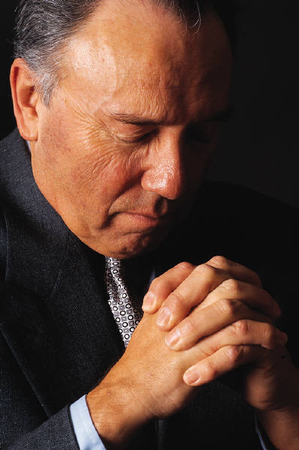
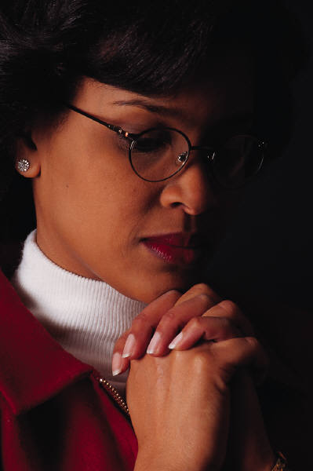

The effectual fervent prayer of a righteous man availeth much
James 5:16

